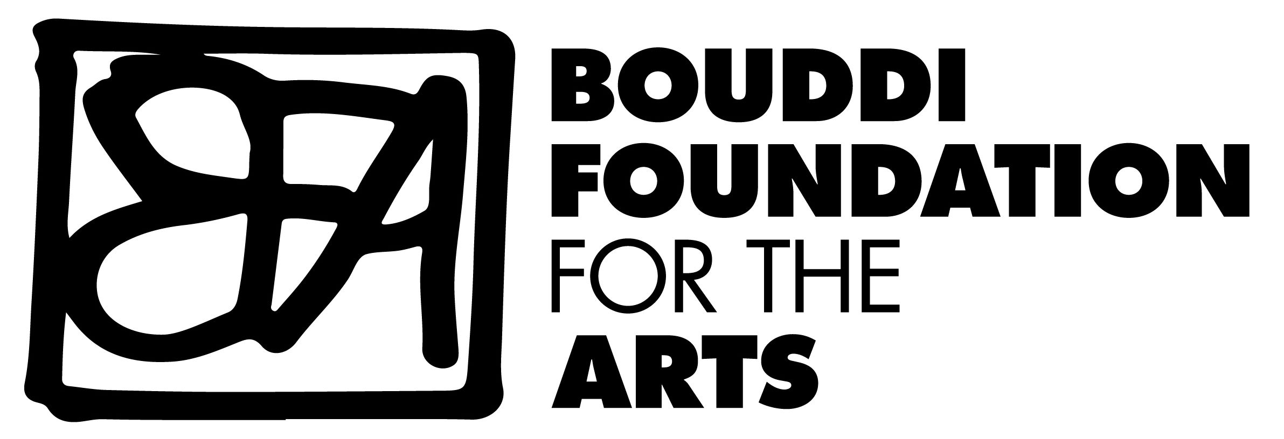

Cheque / Credit Card Donation Form

Donor's Name/Company name:_______________________________________

Address (to send receipt):__________________________________________

__________________________________________________________________

State______________ Postcode:_______________

Phone:_______________________________________

Donation amount: $________

( ) Cheque enclosed or

( ) Please debit my credit card: Visa / Mastercard / Amex

Credit Card Number:______________________________________________

Card Holder's Name: ___________________________Expiry Date:________

Signature:__________________________________

The Bouddi Foundation for the Arts gratefully acknowledges your support.
*AII donations over $5 will receive an official tax receipt

Please return to:- The Bouddi Foundation for the Arts
PO Box 4081
WAGSTAFFE NSW 2267

Or scan and email to phildonnelly1@bigpond.com

